**Year 10 Physics Speed Investigation**

*Based on Activity 8.1 Pg 260 Pearson Science 10*

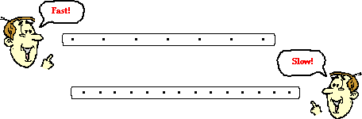

*Your task is to determine how the speed of a toy car/trolley changes depending upon the slope of the surface it is rolled down.*

Your group will choose two angles to push your toy car/trolley down and use ticker tape to measure the speed at which it travels.

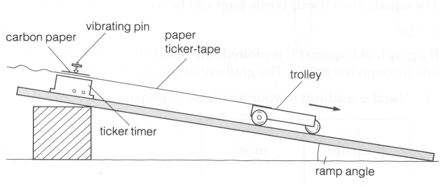

The force of your push (and other things) will need to be kept constant.

The experiment will be conducted more than once on each angle.

You will need to produce two speed time graphs (see fig 8.1.22 pg 260). To do this you will need to make sure you do enough trials so everyone in your group can produce a graph for each angle.

You will work out an average speed for your vehicle on each surface. In your conclusion you will compare these speeds and research reasons for any differences.

Please read the marking key carefully as it outlines what is required in each section of your investigation.

Name:_____________________________

|  |  |  |  |
| --- | --- | --- | --- |
| *These should form subheadings in your work* | **Details** | **Available**  **mark** | **Your**  **mark** |
| **Title** | Descriptive - NOT “Physics Investigation”. Describe what we are testing. | 1 |  |
| **Aim** | Why are you doing this experiment? What do you want to find out? | 1 |  |
| **Introduction** | A short background into assumed science knowledge: Describe how ticker timers work and what do we know about ramps? (Use other sources here). | 2 |  |
| **Hypothesis** | Correctly worded – no personal language.  Includes dependent and independent variables | 2 |  |
| **Independent Variable** | The variable that is changed. When you change the independent variable the variable you are measuring (the dependent variable) will probably change too. | 1 |  |
| **Dependent Variable** | The variable you are measuring. Any change in this variable depends on what you do to the independent variable. | 1 |  |
| **Controlled Variables** | All the things you keep the same to make it a fair test. You should usually list at least three. | 3 |  |
| **Materials** | Complete  Listed  Detail (include number used and amount)  Eg: 25g of salt or 3 x 250ml beakers | 2 |  |
| **Method** | * Step by step with numbers * Written in past tense * Complete * Labelled Diagrams or photos – referred to in text * Explain how reliable results are achieved - trials/replicates, how variables are controlled | 1  1  1  2  3 |  |
| **Results** | Table - neat & clear with units  Must have title | 3 |  |
| **Calculations** | Full working, correct units | 3 |  |
| **Graph** | Includes Title, labels on each axis, correct units, regular spaced, legend for each graph. Use a ruler, do it in pencil and make it neat. | 5 |  |
| **Discussion** | * What did your results show? Use numbers * Errors * Effects of errors on results * Solutions to avoid errors next time | 1  1  1  1 |  |
| **Conclusion** | * What did the results show? * Does this support your hypothesis? * Scientific reasons – YOU NEED TO DO SOME RESEARCH FOR THIS PART (why did we get the results?) | 1  1  3 |  |
| **Presentation** | * Neat * Correct use of subtitles * In correct order | 3 |  |
| **References** | * As described in your diary | 1 |  |
| **Total mark** | | **45** |  |

**Teacher comment: see Seqta.**